Course: CSE:221, Quiz: 2, Time: 30 Minutes

Syllabus: BFS, DFS, Topological Sort, SCC and Quicksort

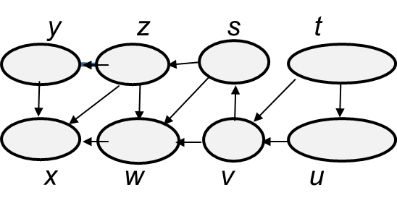

1. Consider the following directed graph for answering all the questions.
2. Generate DFS tree and determine the discovery and finishing time for the vertices. Consider the vertices in alphabetical order.
3. Find out the Strongly Connected Components and Explain it’s Time Complexity.
4. **Is it possible to find out topological ordering of the above graph? If possible, show the ordering. If not possible, state why?**
5. Show that Sum of lengths of all adj. lists is for **Directed Graph is: |E|** and **an Undirected Graph is: 2|E|.**
6. What is Balanced Partitioning? Assume for Quicksort in partitioning algorithm you always divides the array elements into 9-to-1 proportional split. Then answer the following questions:
7. Write down Recurrence Relation.
8. Draw the Recursion Tree.
9. Compute Total Cost.